**MPLS L1**

991451344

Professor: Felix Carapaica

Timothy Pang

**Introduction**

In this lab, we are learning the functioning mechanics of an MPLS core, how it works. We learn how to set up the topology and configure in GNS3.

**Objectives**

* Discover how MPLS labels are generated
* Discover how the MPLS labels are exchanged
* Discover how the labels are installed by routers
* View the structure of the MPLS forwarding table
* View the encapsulation of IPv4 packets into MPLS packets

**Part 1**

**Mechanics of MPLS and LDP**

**R4 mpls forwarding table after enabling on interface f1/0**

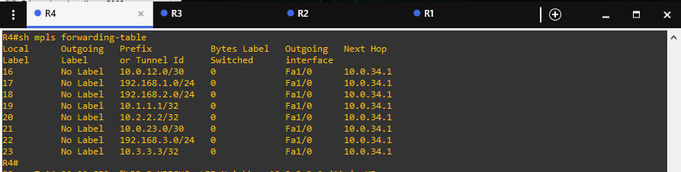

Figure 1.

**Explanation**

When enabling mpls ip in interface f1/0, there are no outgoing labels or bytes switching because mpls ip is only enabled on one interface and the other router does not have mpls ip enabled. Looking at the data/snippets that was accumulated mpls ip does not give labels to directly connected devices rather the devices the other connections are connected to. Looking at the local labels, because MPLS has designated 1 to 14 in a cisco router as special cases, the number skips one and starts at 16, each time the router has a path the number increases by 1. Every connection has a local label that is in someway directly connected to each other.

**R4 mpls forwarding table after adding R3 interface f1/0**

Figure 2.

**R3 mpls forwarding table after enabling interface f1/0**

Figure 3.

**Explanation**

After adding mpls ip to R3 interface f1/0, which is directly connected to R4, the table on R4 gets filled with the Pop labels and the outgoing interfaces. Within the forwarding table of R4, the label called pop label is added to the connections going out of R3. As well as when viewing within the forwarding table of R3, the pop label is added to the outgoing interfaces of R4.

**R3 mpls forwarding table after adding interface f1/1**

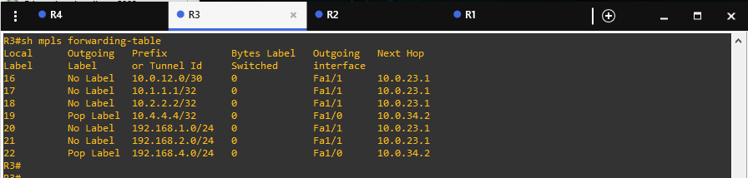

Figure 4.

**Explanation**

After adding mpls ip on interface f1/1 of R3, there is no change in the labels due to the fact that mpls ip is not enabled in the interface connecting from R2, so it does not recognize any outgoing labels.

**R2 mpls forwarding table after adding R3**

Figure 5.

**Explanation**

After enabling mpls ip on the interface f1/1 in R2, the forwarding table gets populated with the updated labels. The pop labels get added to the connections that are connected from R3 instead of from R2. There is no outgoing label for R1, and the network connected to R1 because mpls ip is not enabled on any of the interfaces of R1, however they are still statically connected so that is why they show up on the forwarding-table. In R2, compared to R3 and R4, the local labels are labeled to different addresses.

**R1 mpls forwarding table after adding R2 interface f1/0**

Figure 6.

**Explanation**

Looking inside R1’s mpls forwarding-table, there is no data after adding mpls ip in R2’s interface f1/0 because mpls ip is not activated/enabled on the connection coming out from R1 to R2.

**R1 mpls forwarding table after adding R1 int f1/0**

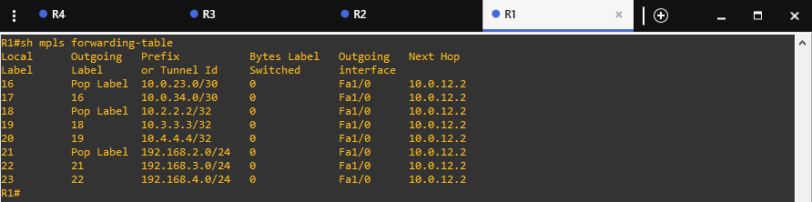

Figure 7.

**Explanation**

With adding mpls ip to the connection from R1 to R2 the forwarding-table in R1 gets populated with the updated local labels for the outgoing interfaces. R2 which is the neighbor to R1 gets all of its routes designated as pop labels, the other labels depend on the route and how long it would take the packets to travel. The labels that have numbers on the outgoing labels coincide with the designated local interfaces depending on where they are connected, and which interface is the next hop. The local labels are updated to whichever route the router is directly connected to.

**Diagrams**

**R1**

From

19

Pop label

18

Pop label

No label

16

10.0.34.0/30

10.0.23.0/30

10.0.12.0/30

R1

Pop label

192.168.1.0 /24

192.168.4.0 /24

192.168.3.0 /24

192.168.2.0/24

22

21

No label

Figure 8.

**R2**

From

Pop label

Pop label

16

Pop label

No label

No label

R2

10.0.34.0/30

10.0.23.0/30

10.0.12.0/30

Pop label

Pop label

17

No label

192.168.1.0 /24

192.168.4.0 /24

192.168.3.0 /24

192.168.2.0/24

**R3**

Figure 9.

**R3**

From

Pop label

Pop label

21

Pop label

No label

No label

R3

10.0.34.0/30

10.0.23.0/30

10.0.12.0/30

Pop label

Pop label

No label

22

192.168.3.0 /24

192.168.1.0 /24

192.168.4.0 /24

192.168.2.0/24

Figure 10.

**R4**

From

Pop label

18

19

Pop label

No label

22

R4

10.0.34.0/30

10.0.23.0/30

10.0.12.0/30

Pop label

No label

192.168.4.0 /24

21

192.168.1.0 /24

192.168.3.0 /24

192.168.2.0/24

20

Figure 11.

**Part 2**

**MPLS Layer 3 VPVn4, PE-CE static**

**Diagram**

Local / Outgoing

**R4**

**R3**

**R2**

**R1**

R3

16 / 25

R2

16 / 25

VPN-A network

VPN-A network

R3

19 / 25

R2

18 / 25

VPN-A network

VPN-A network

R3

16 / 28

R2

16 / 28

VPN-B network

VPN-B network

R3

19 / 28

R2

18 / 28

VPN-B network

VPN-B network

Figure 12.

**R1 mpls forwarding-table 10.4.4.4**

Figure 13.

**R2 mpls forwarding-table 10.4.4.4**

Figure 14.

**R3 mpls forwarding-table 10.4.4.4**

Figure 15.

**Traceroute from R5 to 10.6.6.6**

Figure 16.

**Traceroute from R6 to 10.5.5.5**

Figure 17.

**Trace route from R7 to 10.8.8.8**

Figure 18.

**Traceroute from R8 to 10.7.7.7**

Figure 18.

**MPLS**

Looking at the function of MPLS Layer 3 VPNv4 model, based on the information collected from the trace route, the MPLS core acts as an intermediary to transfer information quick between two vpn’s over an area larger than the current network allows. Looking at the trace route from R1,2, the outgoing labels are equal paths and the one from R3 to R4 is a pop label. The MPLS core is a way for networks over long distances to communicate with each other easily. The protocol used within the mpls core is OSPF and BGP is used for communicating between the VPN’s that are in different areas.

**Configurations**

**R1**

Figure 19.

**R2**

**Figure 20.**

**R3**

Figure 21.

**R4**

Figure 22.

**R5**

Figure 23.

**R6**

Figure 24.

**R7**

Figure 25.

**R8**

Figure 26.